1.Add a CHECK constraint to passenger table to provide that passengers must be at least 10 years old.
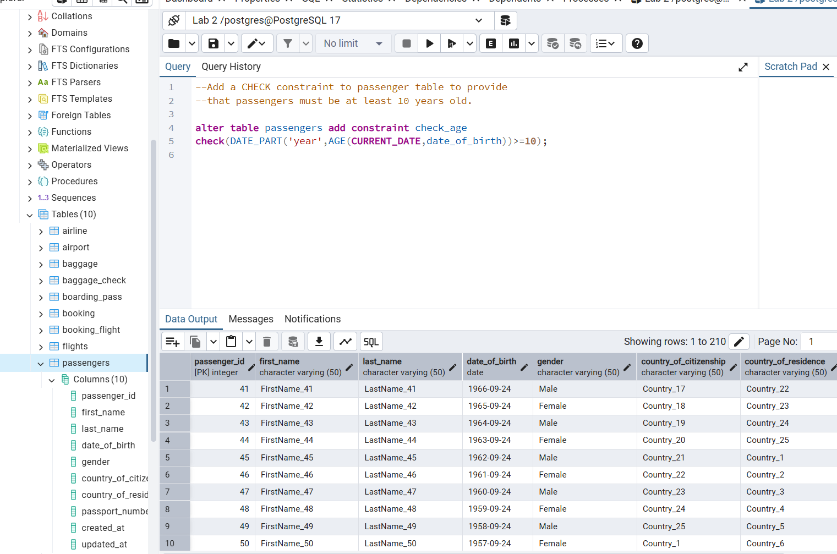
2. Add a CHECK constraint to accept values in booking price not more than 50000tg and less than 0tg.
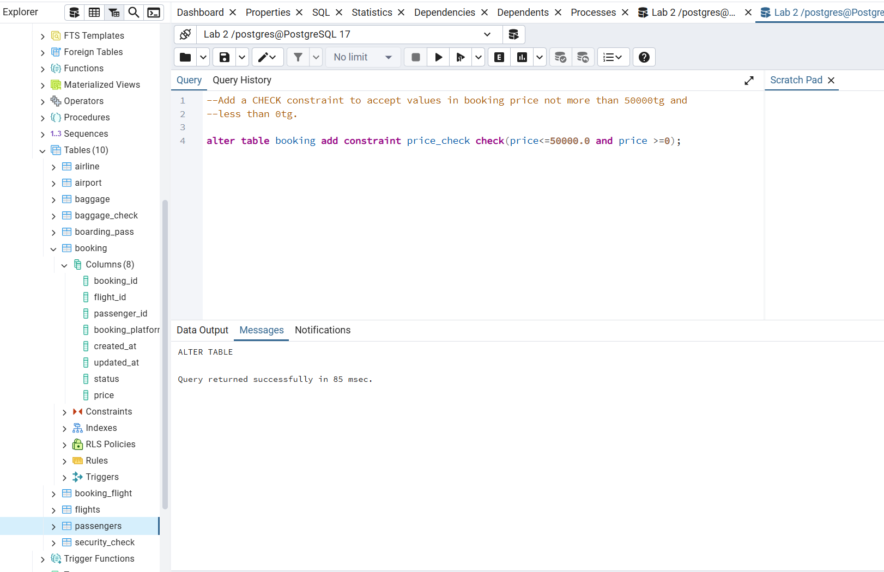
3. Add a CHECK constraint to accept the luggage weight between 1 and 23 kg.
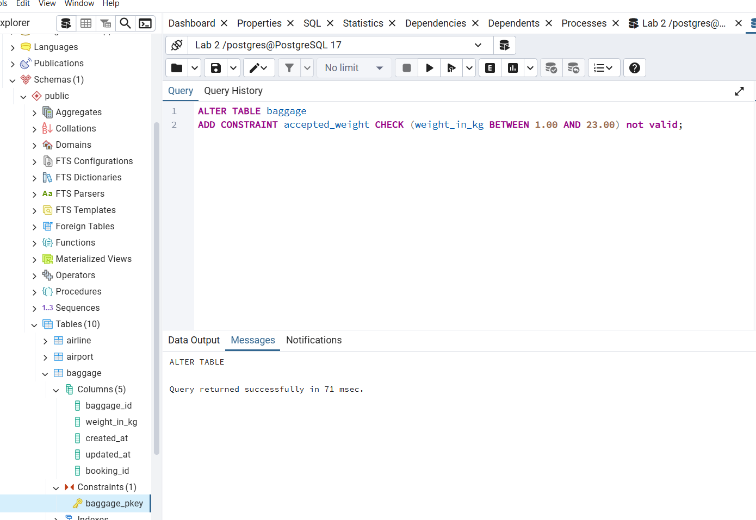
4. Add a CHECK constraint to ensure that all values in airport_name must have at least 10 characters.
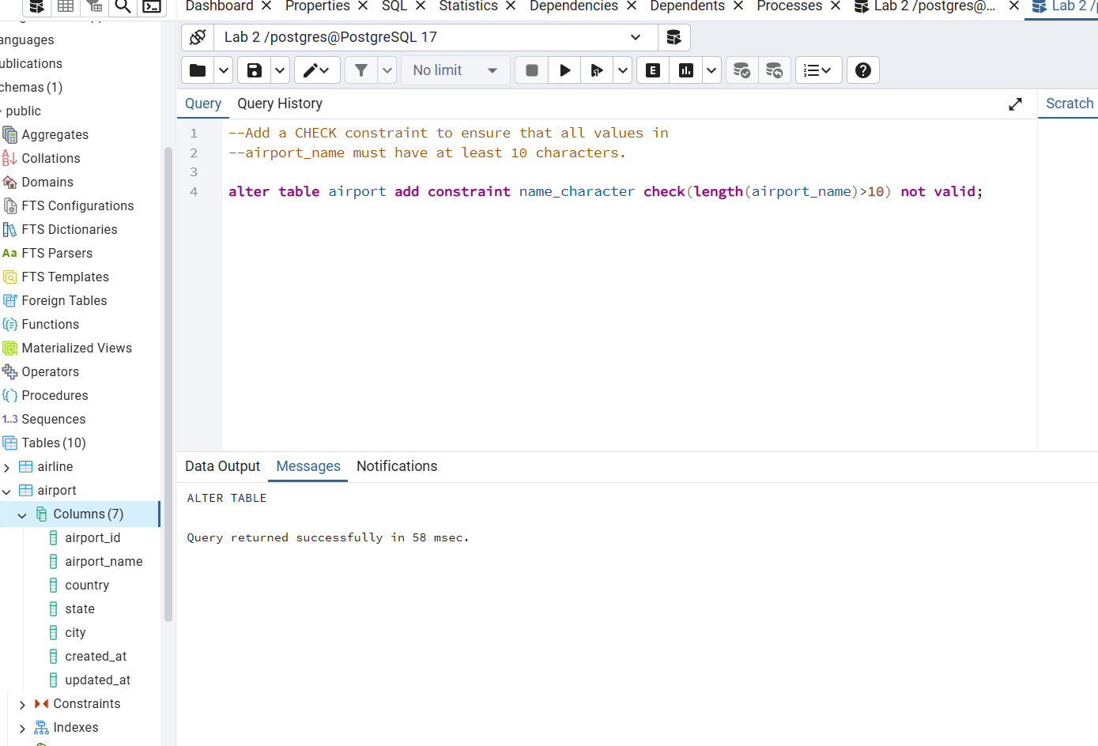
5. Add UNIQUE constraint to some columns in each table in database.
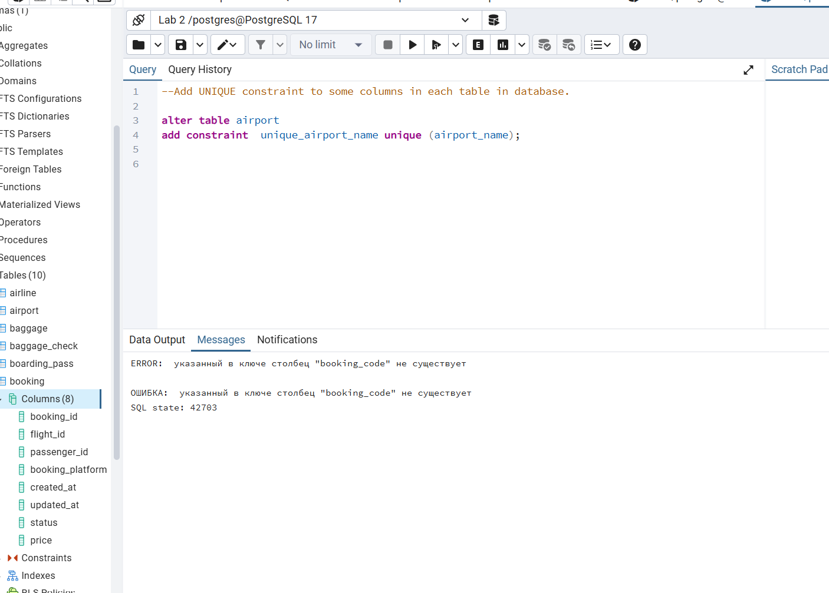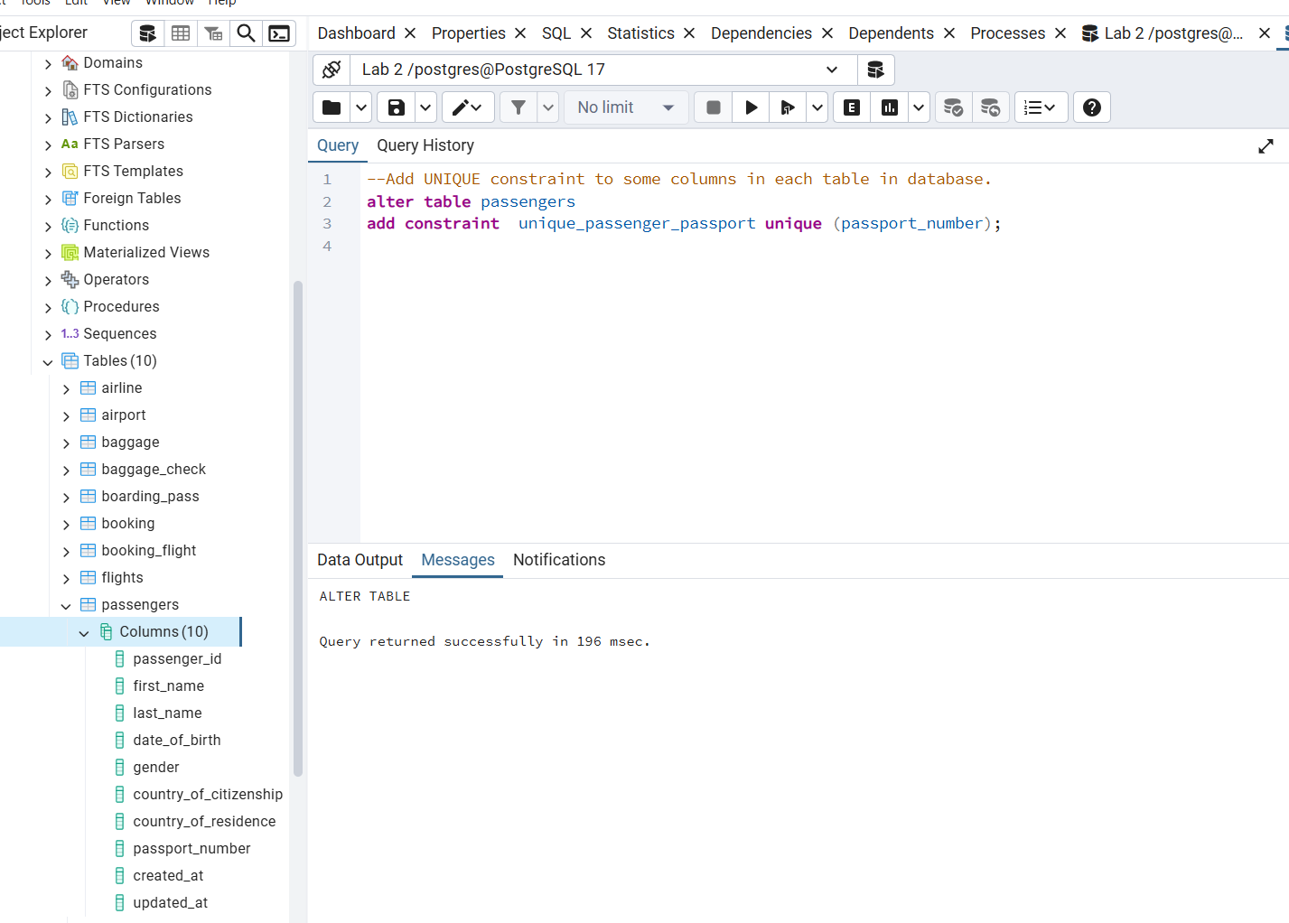

6. Add a CHECK constraint to ensure that male passengers must be at least 18 years old and female passengers must be 19 years old.
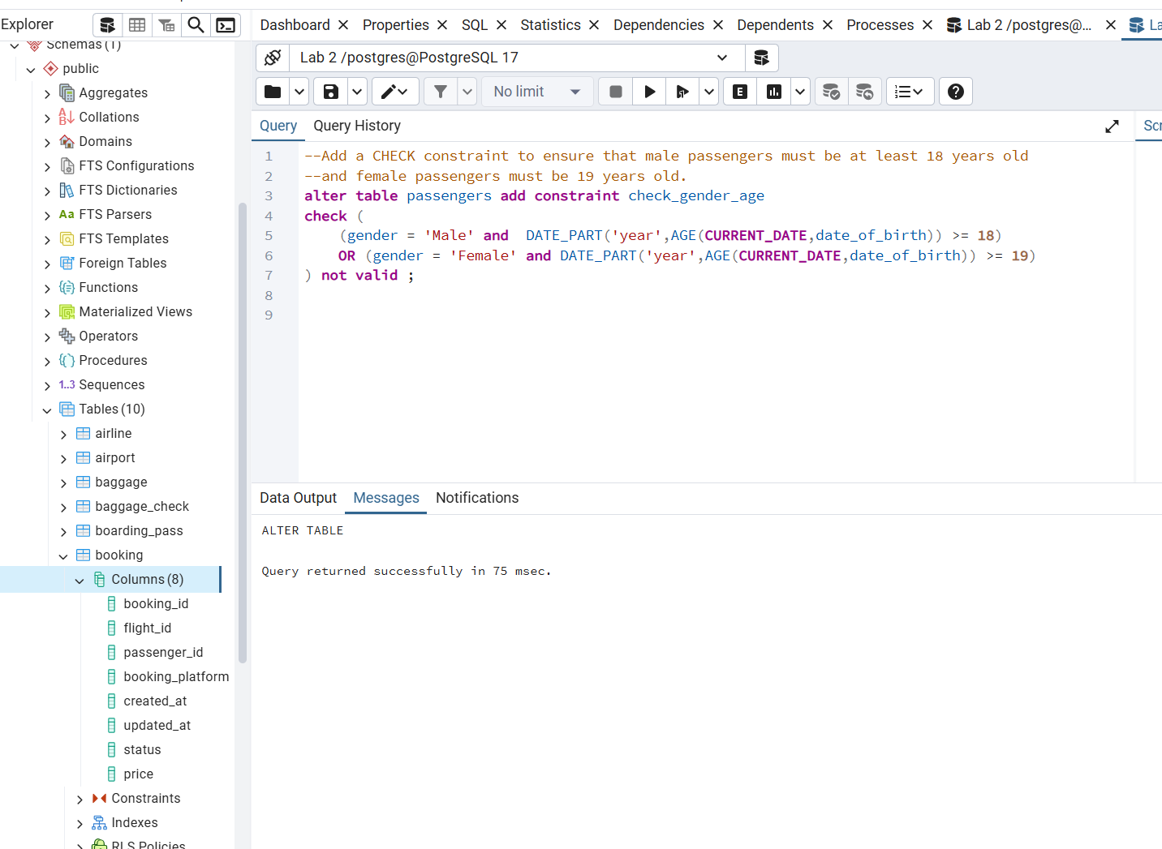
7. Add a CHECK constraint to add rule as follow (use column country_of_citizenship):
· Passengers from Kazakhstan must be at least 18 years old.
· Passengers from France must be at least 17 years old.
· Passengers from other countries must be at least 19 years old.
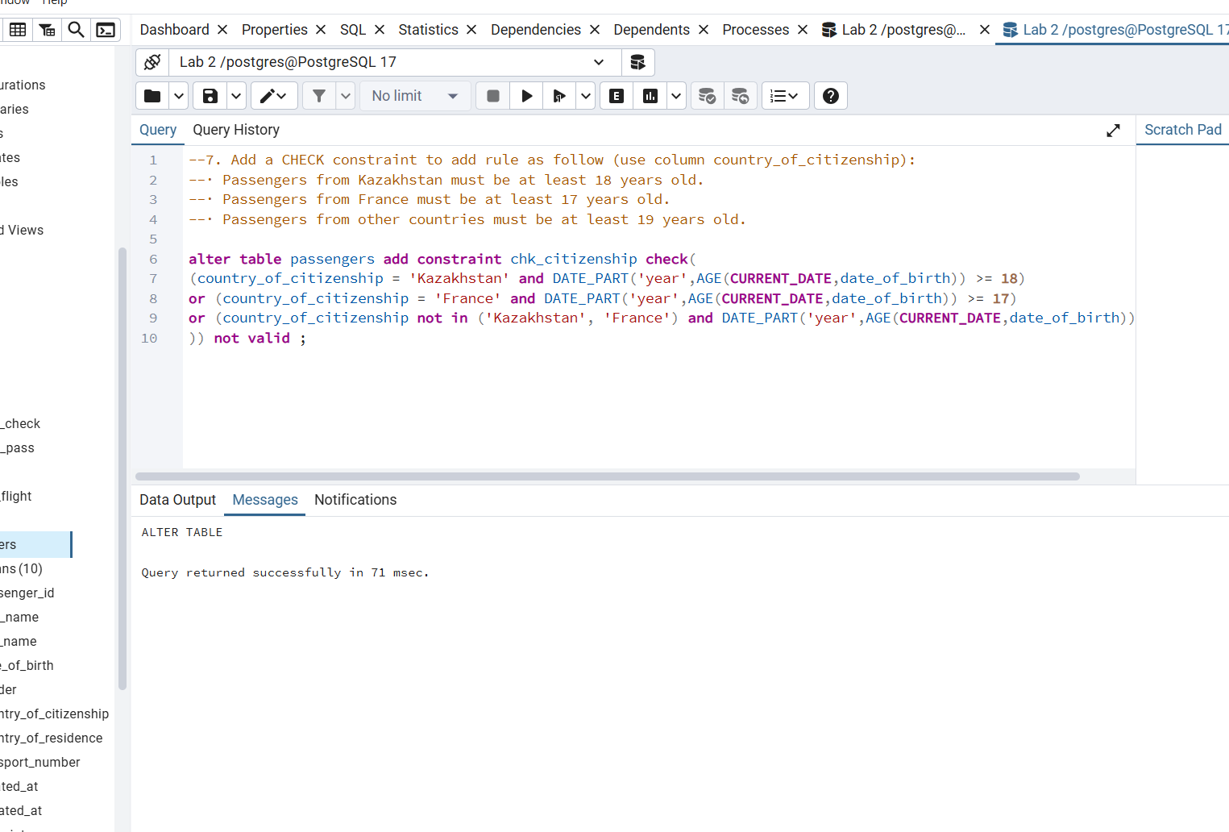
8. Add a ticket_discount column to table booking and a CHECK constraint to apply some discount based on ticket price and created time:
· the constraint applies a 5% discount for tickets created after 2024-01-01,
and 10% discount for tickets created before 2024-01-01
